**AV Dictionarypedia**

Introduction:

This is an audio-visual dictionary application takes the input from the user and search the meaning of the given word from provided dataset for the matches and display as an output the meaning and discerption of the searched word in details with audio for the better understanding of the user.

If the user search wrong spellings this application will show the correct spelling and provide the proper output with detailed meaning with the audio.

Contribution:

* Samannita Banerjee - 20181045 (Coding and Debugging)
* Debarthi Saha - L20191071 (Coding)
* Madhumay Bhattacharjee - L20191072(Debugging and Documentation)
* Pallabi Singha – 20181060 (Documentation)

Methods:

* **pyttsx3** : Text-to-speech conversion library in Python
* **pyaudio** : Set of Python bindings for Port Audio.
* **tkinter** : Tkinter is Python's de-facto standard GUI package.
* **PIL** : Provides image processing capabilities
* **Json :** JSON is a syntax for storing and exchanging data.
* **get_close_matches :** Return a list of the best “good enough” matches.

Proposed system:

Flowchart

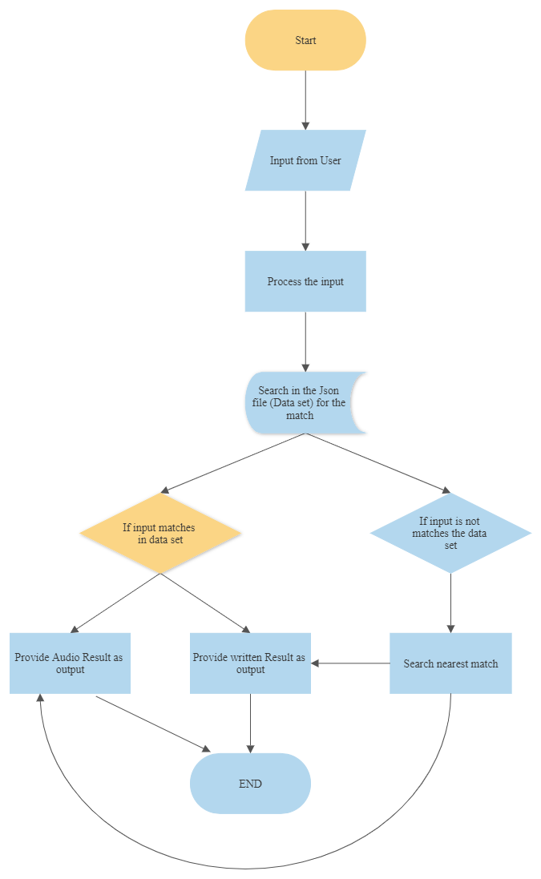

Test case output

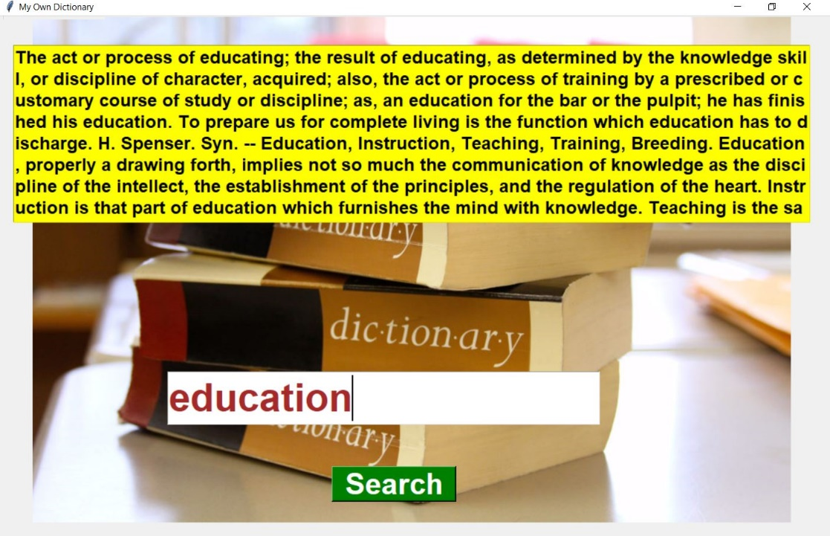

Conclusion:

The userwill get to knowledge of proper English without internet and the audio description will help in improving the way of understanding with reading the words at a same time.

Users don’t need internet at all to use this application.

References:

Google and related applications